Data Mining
Semester Project
Project Name: Project Name
Project Team:
- Student Name 1انس صالح إبراهيم العطيوى (320230601061)

- Datasets
  - Use Kaggle website ( https://www.kaggle.com/datasets ) for selecting datasets
Table 1: All datasets
Dataset Name | Dataset Link | Field  (Domain) | No of Features | No of Instances (records) | Binary Class or Multi-class  (Mention them
Student Performance Prediction || EDA || ML | https://www.kaggle.com/code/ahmedabbas757/student-performance-prediction-eda-ml/input | Predicting students' success or failure | 6 | 10000 | Binary
Student Academic Performance Analysis 📚📈 | https://www.kaggle.com/code/bhartiprasad17/student-academic-performance-analysis/input | Predicting students' success or failure | 8 | 1000 | Binary

(Student Performance Prediction || EDA || ML)

  - Visualization of Dataset
  - ##Correlation Heatmap
  - corr = df.corr()
  - plt.figure(figsize=(8,6))
  - sns.heatmap(corr, annot=True, cmap="coolwarm", fmt=".2f")
  - plt.title("Feature Correlation Heatmap")
  - plt.show()

  - 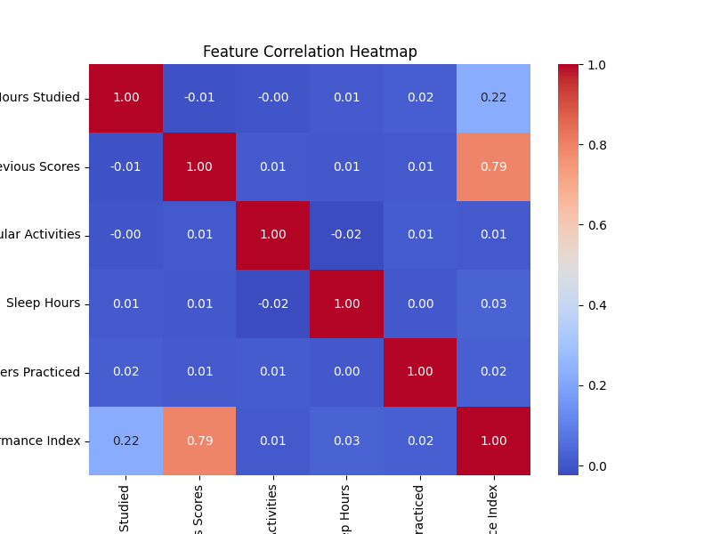

Insert a visualization that shows the classes’ distribution in the selected datasets.
# Class Distribution
plt.figure(figsize=(8, 4))
sns.countplot(x=y)
plt.title("Performance Index (0 =Filed , 1 = Successful)")
plt.xlabel("Performance Index")
plt.ylabel("Count")
plt.show()
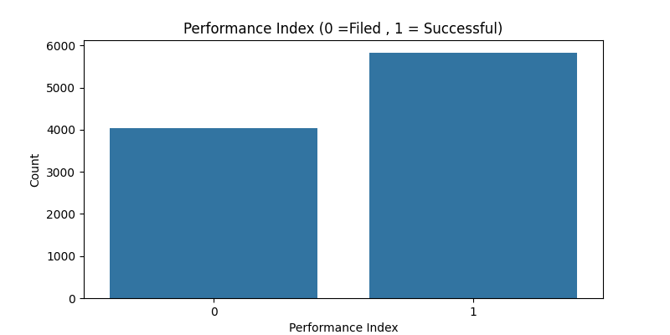
- The proposed model
  - Pre-processing step
(mention the pre-process techniques) 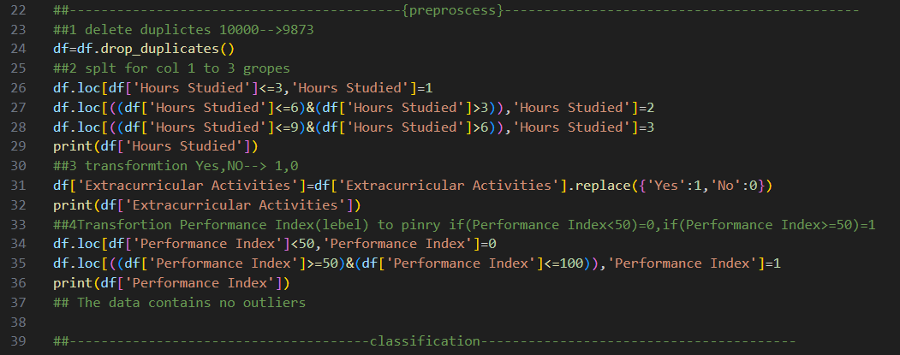
  - Classifiers (Machine learning algorithms)
(Describe briefly the selected classifiers)
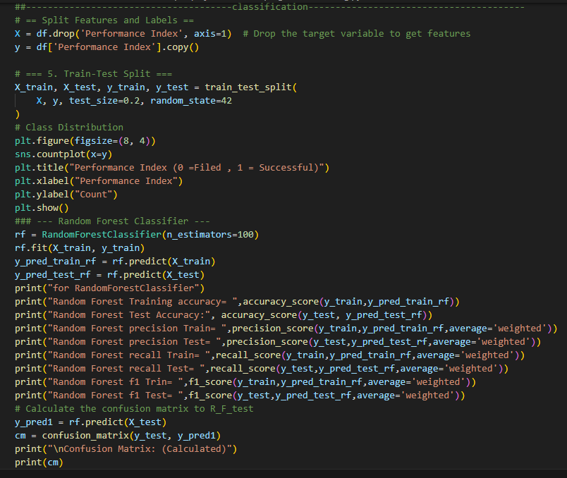
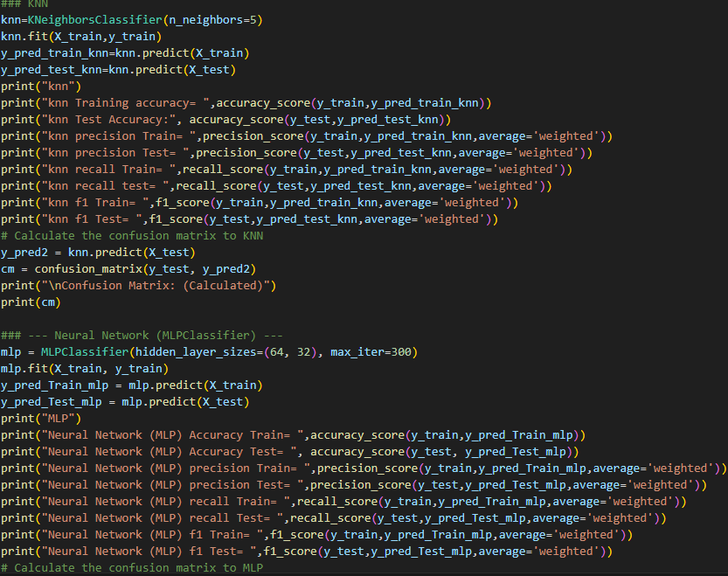
*I chose the best three according to accuracy classifiers 1-(MLP) 2-Random forest 3-KNN
*test_ size=0.2 is better than test_ size=0.3 in terms of accuracy , based on my experience
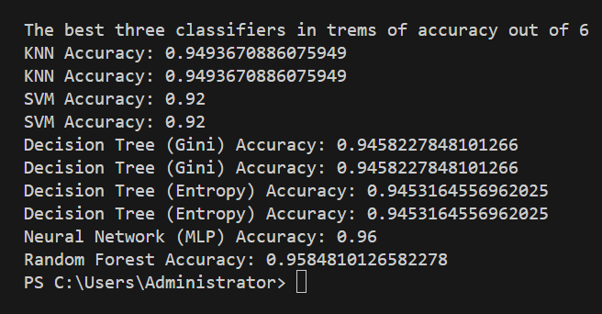

- Results and Discussion
  - Accuracy/ Precision/ Recall/ F1*Score/ Confusion Matrix/ROC for Model Training

Table: Results of Accuracy, Precision, Recall, and F1*Score for Model Training

Model (Random Forest/ Decision Tree/ SVM/ Naïve Byes/ Neural Networks/ KNN/ ..... | Accuracy | Precision | Recall | F1-Score
Model 1(R_F) | 0.9916434540389972 | 0.9916428316849465 | 0.9916434540389972 | 0.9916430773462441
Model 2 (KNN) | 0.9625221575082299 | 0.9625083339828747 | 0.9625221575082299 | 0.962513657841657
Model 3(MLP) | 0.9596100278551533 | 0.9595827878757991 | 0.9596100278551533 | 0.9595811691658224

Figure4: ROC for all models
Insert here

  - Accuracy/ Precision/ Recall/ F1*Score/ Confusion Matrix/ROC for Model Testing

Table: Results of Accuracy, Precision, Recall, and F1*Score for Model Testing

Model (Random Forest/ Decision Tree/ SVM/ Naïve Byes/ Neural Networks/ KNN/ ..... | Accuracy | Precision | Recall | F1-Score
Model 1(R_ f) | 0.9579746835443038 | 0.9582815494443028 | 0.9579746835443038 | 0.9580544146070888
Model 2(KNN) | 0.9493670886075949 | 0.9497335432446097 | 0.9493670886075949 | 0.9494685336907677
Model 3(MLP) | 0. 0.9635443037974684 | 0.963643917079725 | 0.9635443037974684 | 0.9635776235198039
….

Figure1: Confusion Matrix of Model1(R_F) Testing
Insert here Confusion Matrix: (Calculated)
[[ 738 33]
[ 50 1154]]
Figure2: Confusion Matrix of Model2(KNN) Testing
Insert here Confusion Matrix: (Calculated)
[[ 730 41]
[ 59 1145]]
Figure3: Confusion Matrix of Model3 Testing
Insert here
Confusion Matrix: (Calculated)
[[ 748 23]
[ 57 1147]]
Figure4: ROC for all models
Insert here
  - Results Discussion
The results show that ……. 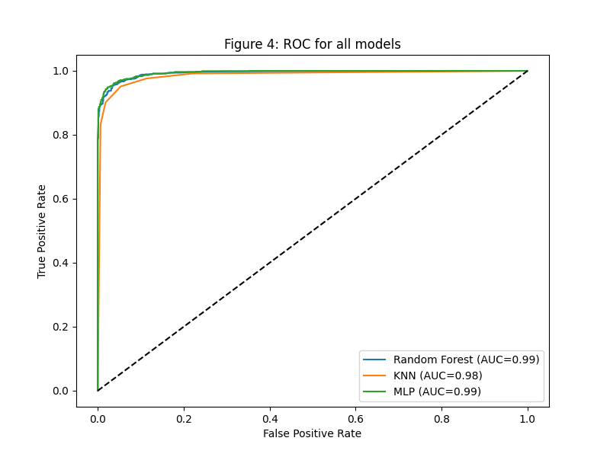

أولا كان من صعب العثور على 2 داتا سيت نفس العنوان مختلفات البينات لكن وجدة بينات تنبؤ بنجاح ورسوب الطلاب الخيار الأفضل عمليات التنظيف وتصحيح للبينات كانت بسيطة وترتكز على تحويل الاعمدة من بينات نصية الى بينات رقمية وحذف التكرار وكانت البينات خاليا من البينات الشاذة مما جعل الامر اسهل وكانت الإضافة التي فكرت فيها تعديل العامود الأول (ساعات الدراسة) كانت ساعة الدراسة تتراوح بين (1_9) ثم جعلتها ثلث مجموعات كل ثلث ساعات في مجموعة مما جعل دقة تدريب المشروع اعلى واخر تعديل العامود الأخير العلامات النهائية حولتها الى ناجح او راسب لجعل البينات ثنائية( ناجح / راسب) من ثم كان اختيار تقسيم البينات الى( تدريب /فحص) .. بعد التجربة اتضح انه 20%فحص /80%تدريب افضل شيء ومن ثم اختيرا انوع الخوارزميات او التقنيات المستخدمة وجدت j افضل ثلاث تقنيات من اصل 6
*I chose the best three according to accuracy classifiers 1-(MLP) 2-Random forest 3-KNN
*test_ size=0.2 is better than test_ size=0.3 in terms of accuracy , based on my experience

اما النتائج كانت جيدة بين( 94_96 )

- Python Code
- import pandas as pd
- import matplotlib.pyplot as plt
- import seaborn as sns
- import numpy as np
- from sklearn.preprocessing import LabelEncoder
- from sklearn.model_selection import train_test_split
- from sklearn.metrics import accuracy_score, precision_score, recall_score, f1_score, confusion_matrix, ConfusionMatrixDisplay,roc_curve, auc
- from sklearn.ensemble import RandomForestClassifier
- from sklearn.neighbors import KNeighborsClassifier

- from sklearn.svm import SVC
- from sklearn.tree import DecisionTreeClassifier
- from sklearn.neural_network import MLPClassifier
- from sklearn.ensemble import RandomForestClassifier

- # = Load Preprocessed CSV Data set1&& Data set2 =
- url=(r'C:\Users\Administrator\AppData\Roaming\Microsoft\Windows\Network Shortcuts\dataset2.csv')
- df=pd.read_csv(url)
- print("data oraginal\n",df)
- print("max_Hours Studied= ",df['Hours Studied'].max(),"Hours Studied_min= ",df['Hours Studied'].min())
- ##------------------------------------------{preproscess}---------------------------------------------
- ##1 delete duplictes 10000-->9873
- df=df.drop_duplicates()
- ##2 splt for col 1 to 3 gropes
- df.loc[df['Hours Studied']<=3,'Hours Studied']=1
- df.loc[((df['Hours Studied']<=6)&(df['Hours Studied']>3)),'Hours Studied']=2
- df.loc[((df['Hours Studied']<=9)&(df['Hours Studied']>6)),'Hours Studied']=3
- print(df['Hours Studied'])
- ##3 transformtion Yes,NO--> 1,0
- df['Extracurricular Activities']=df['Extracurricular Activities'].replace({'Yes':1,'No':0})
- print(df['Extracurricular Activities'])
- ##4Transfortion Performance Index(lebel) to pinry if(Performance Index<50)=0,if(Performance Index>=50)=1
- df.loc[df['Performance Index']<50,'Performance Index']=0
- df.loc[((df['Performance Index']>=50)&(df['Performance Index']<=100)),'Performance Index']=1
- print(df['Performance Index'])
- ## The data contains no outliers

- ##--------------------------------------classification----------------------------------------
- # == Split Features and Labels ==
- X = df.drop('Performance Index', axis=1) # Drop the target variable to get features
- y = df['Performance Index'].copy()

- # === 5. Train-Test Split ===
- X_train, X_test, y_train, y_test = train_test_split(
- X, y, test_size=0.2, random_state=42
- )
- # Class Distribution
- plt.figure(figsize=(8, 4))
- sns.countplot(x=y)
- plt.title("Performance Index (0 =Filed , 1 = Successful)")
- plt.xlabel("Performance Index")
- plt.ylabel("Count")
- plt.show()
- ### --- Random Forest Classifier ---
- rf = RandomForestClassifier(n_estimators=100)
- rf.fit(X_train, y_train)
- y_pred_train_rf = rf.predict(X_train)
- y_pred_test_rf = rf.predict(X_test)
- print("for RandomForestClassifier")
- print("Random Forest Training accuracy= ",accuracy_score(y_train,y_pred_train_rf))
- print("Random Forest Test Accuracy:", accuracy_score(y_test, y_pred_test_rf))
- print("Random Forest precision Train= ",precision_score(y_train,y_pred_train_rf,average='weighted'))
- print("Random Forest precision Test= ",precision_score(y_test,y_pred_test_rf,average='weighted'))
- print("Random Forest recall Train= ",recall_score(y_train,y_pred_train_rf,average='weighted'))
- print("Random Forest recall Test= ",recall_score(y_test,y_pred_test_rf,average='weighted'))
- print("Random Forest f1 Trin= ",f1_score(y_train,y_pred_train_rf,average='weighted'))
- print("Random Forest f1 Test= ",f1_score(y_test,y_pred_test_rf,average='weighted'))
- # Calculate the confusion matrix to R_F_test
- y_pred1 = rf.predict(X_test)
- cm = confusion_matrix(y_test, y_pred1)
- print("\nConfusion Matrix: (Calculated)")
- print(cm)
- ### KNN
- knn=KNeighborsClassifier(n_neighbors=5)
- knn.fit(X_train,y_train)
- y_pred_train_knn=knn.predict(X_train)
- y_pred_test_knn=knn.predict(X_test)
- print("knn")
- print("knn Training accuracy= ",accuracy_score(y_train,y_pred_train_knn))
- print("knn Test Accuracy:", accuracy_score(y_test,y_pred_test_knn))
- print("knn precision Train= ",precision_score(y_train,y_pred_train_knn,average='weighted'))
- print("knn precision Test= ",precision_score(y_test,y_pred_test_knn,average='weighted'))
- print("knn recall Train= ",recall_score(y_train,y_pred_train_knn,average='weighted'))
- print("knn recall test= ",recall_score(y_test,y_pred_test_knn,average='weighted'))
- print("knn f1 Train= ",f1_score(y_train,y_pred_train_knn,average='weighted'))
- print("knn f1 Test= ",f1_score(y_test,y_pred_test_knn,average='weighted'))
- # Calculate the confusion matrix to KNN
- y_pred2 = knn.predict(X_test)
- cm = confusion_matrix(y_test, y_pred2)
- print("\nConfusion Matrix: (Calculated)")
- print(cm)

- ### --- Neural Network (MLPClassifier) ---
- mlp = MLPClassifier(hidden_layer_sizes=(64, 32), max_iter=300)
- mlp.fit(X_train, y_train)
- y_pred_Train_mlp = mlp.predict(X_train)
- y_pred_Test_mlp = mlp.predict(X_test)
- print("MLP")
- print("Neural Network (MLP) Accuracy Train= ",accuracy_score(y_train,y_pred_Train_mlp))
- print("Neural Network (MLP) Accuracy Test= ", accuracy_score(y_test, y_pred_Test_mlp))
- print("Neural Network (MLP) precision Train= ",precision_score(y_train,y_pred_Train_mlp,average='weighted'))
- print("Neural Network (MLP) precision Test= ",precision_score(y_test,y_pred_Test_mlp,average='weighted'))
- print("Neural Network (MLP) recall Train= ",recall_score(y_train,y_pred_Train_mlp,average='weighted'))
- print("Neural Network (MLP) recall Test= ",recall_score(y_test,y_pred_Test_mlp,average='weighted'))
- print("Neural Network (MLP) f1 Train= ",f1_score(y_train,y_pred_Train_mlp,average='weighted'))
- print("Neural Network (MLP) f1 Test= ",f1_score(y_test,y_pred_Test_mlp,average='weighted'))
- # Calculate the confusion matrix to MLP
- y_pred3 = mlp.predict(X_test)
- cm = confusion_matrix(y_test, y_pred3)
- print("\nConfusion Matrix: (Calculated)")
- print(cm)
- import matplotlib.pyplot as plt
- from sklearn.metrics import roc_curve, auc

- plt.figure(figsize=(8,6))

- # Random Forest
- y_prob_rf = rf.predict_proba(X_test)[:,1]
- fpr, tpr, _ = roc_curve(y_test, y_prob_rf)
- plt.plot(fpr, tpr, label=f"Random Forest (AUC={auc(fpr,tpr):.2f})")

- # KNN
- y_prob_knn = knn.predict_proba(X_test)[:,1]
- fpr, tpr, _ = roc_curve(y_test, y_prob_knn)
- plt.plot(fpr, tpr, label=f"KNN (AUC={auc(fpr,tpr):.2f})")

- # MLP
- y_prob_mlp = mlp.predict_proba(X_test)[:,1]
- fpr, tpr, _ = roc_curve(y_test, y_prob_mlp)
- plt.plot(fpr, tpr, label=f"MLP (AUC={auc(fpr,tpr):.2f})")

- # قاعدخ
- plt.plot([0,1], [0,1], 'k--')

- plt.title("Figure 4: ROC for all models")
- plt.xlabel("False Positive Rate")
- plt.ylabel("True Positive Rate")
- plt.legend()
- plt.show()

